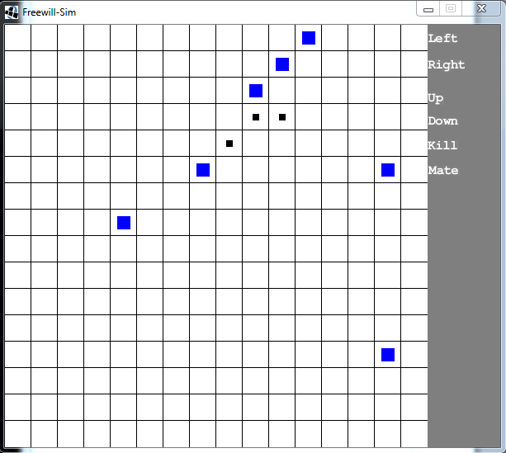
This is a picture of the entire game board, it starts off with 10 grown squares and squares can be born until there are 30 on the board, when there is 30 on the board, a square must be killed in order for another square to be born.

The beings(squares) in this simulation can act by themselves, or you can command them individually. To make them act independently, then you have to hit the space key. To have one act on your command, then you must click on one of the squares until it is selected and then click on an action on the left. (Shown in pictures below).
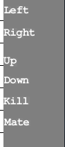
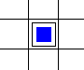
Picture of a selected square. A square will be unselected after every action.
Picture of the actions that a square can do. A square must be next to another square in order to kill or mate.

The beings will move and act randomly. Every time they do an action, they are more likely to do it again. The console on the right will display information as things happen and will tell you whenever a square has died, been born, or has grown up.
This is a picture of two squares that have mated and made a baby square(bottom). Baby squares will grow up after they move/act 18 times.

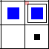
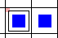
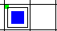

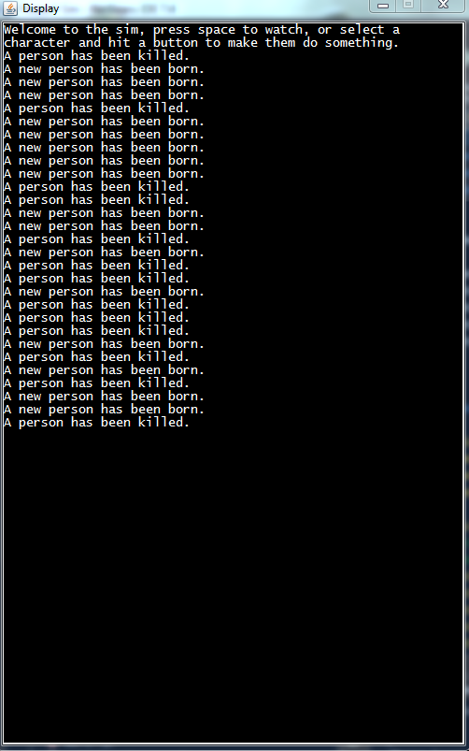
This is a picture of the square on the left killing the square on the right, when a square is killed, they will disappear.
This is a picture of the console display.

That's pretty much it on how to use the program, have fun simulating!

